


About Zbang! the game, and its characters:


"Zbang! The Game" is a comedy game where you play Mike, an average teenager, who likes to surf, play rock'n'roll, and fantasize about having sex with his girlfriend, Jennifer.
In the game you get to meet Mike and his gang of friends and foes.
There’s nothing more trivial than a romantic comedy. There are many great love stories throughout the history of man kind. There were many couples you might remember: Romeo and Juliet, Ross and Rachel, Pam and Michael. Will Mike and Jennifer’s story be written down in history as the worlds’ greatest love story of all times? You’ll be the one calling the shots through your game play.

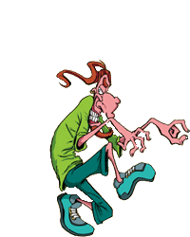
Red - A self centered egotistical, highly intelligent hormone machine that is totally obsessed with Sex. He's Mike's best friend. But don't worry, Mike knows that underneath his revolting exterior lies a self centered egotistical, highly intelligent hormone machine that is totally obsessed with Sex. His hobbies are terrorizing the girls when peeking into dressing-rooms, running away from Bob after the latter discovers Red has been peeking on his beloved girlfriend, Josephine, and reading Penthouse magazines. For the articles, of course.


Jennifer - Mike's girlfriend. Completely devoted to noble causes such as feminism and ecology, she sometimes causes more harm then good due to her over-enthusiasm. She's a devout virgin, much to Mike's dismay. As tough and opinionated as she may seem on the outside, she loves Mike and she knows he loves her because, and not in spite of what she's like.



Daphne - The girl of your wet dreams. A silicon-produced illusion of perfection that hides a cold, calculating, power hungry bitch underneath that great big smile. For years now, this girl has been getting a kick out of replacing one guy with another, and then with another and so on. There is almost no guy who can resist her. Her dream is to become a successful, international model-actress-starlet, and she won’t hesitate to step on people, pushing them back, on her way to fulfilling that dream.


Eugene is Mike's twin brother. He is not just a normal geek, he's SUPER-GEEK! Underneath his glasses, Eugene possesses special skills and abilities, such as being able to quote every line of "Star Trek", running away from girls in the speed of light, and blowing up experiments from time to time. Eugene claims that Harry Potter used his haircut to copy that cool chic of his. We have no comment on that matter.



Ralph “Barf” is the most disgusting kid that has ever been. He likes blood, gore, horror movies, nose buggers and insects. He takes field trips to the local dumpster for a breath of freshly air. For him, the ideal romantic date is to watch dead fish in polluted rivers, and then go and dive hand in hand in the same rivers. For an unclear reason, he does have a girlfriend, Aiisha, who accepts him just the way he is. That is, as one may witness, a very odd relationship indeed.



Aiisha is part of mother earth. She believes in nature, Gaia, and life. She is very spiritual, and some people say they actually saw her floating while she was meditating. She projects harmony and meditation to the outer spheres of the world, and by that (and by dating Ralph) makes the world a far better, nicer and more chi-loaded place.

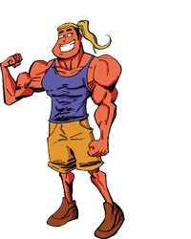

Dylan, Oh yeah, Dylan! That’s what she said.
He uses his muscles, flowing blond hair and piercing blue eyes to get what he wants from all the girls who fall at his feet. The only girl he couldn’t get is his female mirror image, Daphne. Besides being the school's "pretty boy", Dylan tries hard to reach the position of the strongest guy in school. But for that, alas, he still has to beat Bob, the lean, mean muscle machine.



Johnny’s only words when he’s not singing are: Sex, love, Rock N’ roll. He is the lead (and only) singer of the band “My Limping Sister”, which he founded with Mike, Red and Tom. Red is always envious of him, because all of the band's female groupies only care about Johnny. The fact that the band has only two groupies in total doesn't make a difference, of course.
;;


The Principle, It’s very good, in the students' opinion, that the high-authority figure of the school, is a big old infantile child who is obsessed with collecting action figures, watching Japanese anime shows (dubbed of course), and obviously he prefers spending his time playing with his toys in his office, then actually managing the school.
The best time to be sent to the principles office is when Pokemon, or Dragonball Z is on TV.


Donald’s parents lost all their money during the recent high-tech crisis, and the recent global economical drop, so now he’s homeless. He couldn’t be happier, though. he’s easy going, enjoys everything he can in life, and loves his cardboard box of a home that’s behind the bench in the park. There’s nothing that can get on his nerves, and he’s always smiling and laughing, no matter how harsh life can treat him.


Richard – with his nose always turned up, his expensive, fashionable clothes, gadgets and his fancy talk, Richard is utterly the most snobbish guy in the world, or one of them, anyway. He's the type who chooses his company according to the so-called sophistication of their behavior, and tends to disregard the other 99.9% of the world as an "inferior class".



Sharon can be anything, anyone, anytime. All that Sharon has to do in order to use her unnatural skill of "becoming another" is to become the person/thing's groupie. When Sharon defines herself as "a fan of…", her appearance instantly changes to that of her subject of admiration. When you come to think of it, Sharon IS the incarnation of the fandom concept, and has never been seen in her true form, if such even exists.


Sylvia – when she hears the word "sex", especially when said by Johnny, Sylvia jumps to a halt, and starts eyeing the surrounding male specimens in the area. Like Red, she is always horny, but forget not that she is also a woman, and as such, may sometimes be unpredictable, even emotional. In short – this is one horny lady.

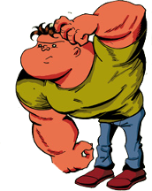
Bob – a nearly-brainless muscle machine, Bob is a very nice, naïve and mighty empty-minded guy. The only thing that had entered his brain in the last few years is the image of his lovely girlfriend, Josephine, whom he simply adores. He may, from time to time, get violent, especially when it comes to protecting Josephine from unwelcome intruders – Red, for example.

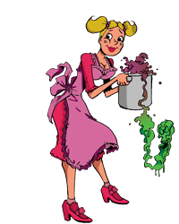
Josephine is a sweet, blond, big-bosomed girl, who used to be the "queen" of her class before Daphne's arrival. One of Josephine's main hobbies is the art of cooking, and she is considered an expert in completely devastating even the easiest-to-make recipes. Her cooking tends to cause sever damage to the surroundings and the environment, especially to Bob, who is already a familiar patient in the line for stomach pumping. Beware when trying her world infamous cheese and chocolate soufflé. Or her peanut butter and chewing gum sandwitch.

Mrs. Grouch – if there would actually be teachers from hell, one glance at Mrs. Grouch would cause them to run away, screaming for help from the devil. She is mean, cruel, and most of all – evil. Surprisingly enough, she's married. Yes, her husband is a pathetic little low-life, who probably just doesn't know what she really looks like, but as long as he loves her, does it really matter?



Benny likes food. He's fat and he doesn't give a damn about it. That just about concludes Benny's character. Food is the thing Benny lives for, and some say that the food lives (and dies) mainly for Benny, which isn't too far from the truth, with him being the nightmare of the modern food industry. When it comes to anything other than food, though, Benny is quite indifferent.
Ever since Benny moves into the neighborhood, there aren’t any more all-you-can-eat places, they went bankrupt after he ate all their food.



Tom is the drummer of "My Limping Sister", and is also openly gay. He's a nice, quiet guy, who usually just goes with the flow and plays Rock N' Roll.

Betty is the proud mother of Ricky, Mike and Eugene. She and her husband, George, try as hard as they can to educate their three frantic teenage kids, but from time to time it seems to her as if she's the only one that's doing something around the house.




George loves his couch-and-TV. Yes, he cares about his wife, Betty, and about their kids… what do you call them…? Ricky, Mike and… the geek one… Eugene! Yes, he cares, see? But as much as he cares, it's time to watch the 9 o’clock news, so he'll mind them later on, sometime. He will. Really.

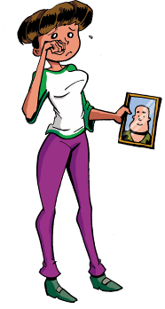

Ricky is the elder sister of the twins Mike and Eugene, and the daughter of Betty and George. She's a fun-loving teenager, who really likes the idea of joining the army, or at least dating selected members in it.



April – just as her name implies, April is the exact opposite of a happy, shiny person. She dresses in black, dyes her hair black, wears black sunglasses at all times, and… you get the point. Everything around her is miserable, flowers crumble to dust and hopes fade away as she passes by. She thought about becoming a vampire but blood is too cheery and colorful.



Ron is the guy you wouldn't like to have even as an imaginary friend. It's not that he's not nice, it's just that he's… too sticky. His way of "hanging out" is to bug every potential friend until the supposed friend runs away screaming, or laughing. Lacking friends, Ron took some comfort in gadgets, and seems to know everything about anything in that field.

The Game’s Environment:
The game takes place in everyday world of high school teenagers:
The school, a typical messy teenage room, band practice, the mall, the beach.
The game will include many plot devices like flashbacks, and changes in the point of view for exposition and exploration of characters.

Websites:
Zbang! - the game's website :
Hebrew - http://corbomitegames.com/zbeng
English - http://corbomitegames.com/zbang

Corbomite Website http://corbomitegames.com/

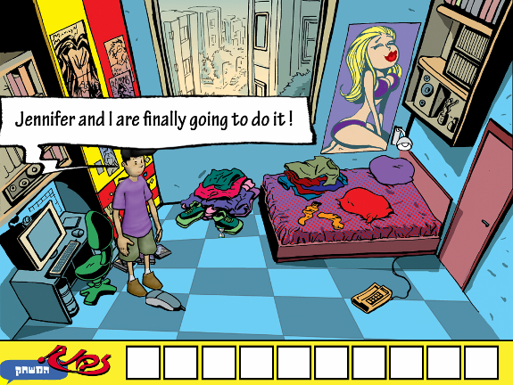
Actual screenshot from the demo game: Mike is sure that he’s going to sleep with Jennifer tonight, but will he?
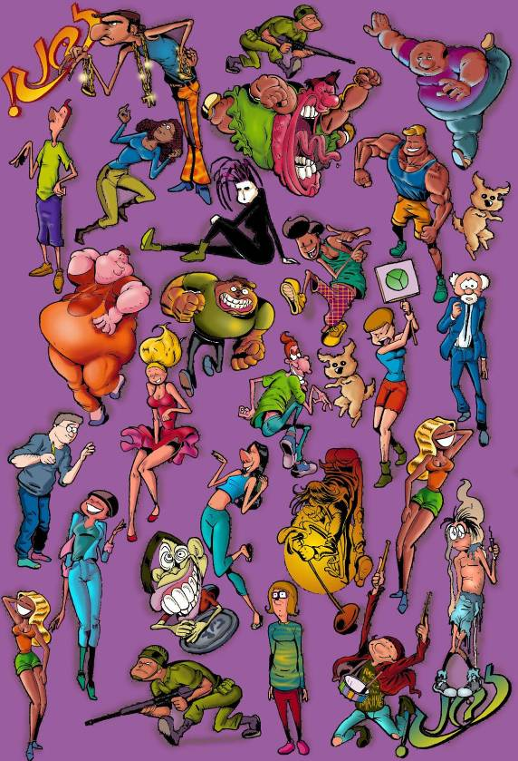A collection of Zbang Characters

Illustration example: Evolution of modern man

